State algorithm
First we need to detect the part and obtain its pose. The camera node provides this information.
Next we need to compute how to grasp the part. In the ROS system for our factory, we have a GraspPlanner node that, given the pose of the part, returns the robot joint configuration needed to pick it.
Once we have this joint configuration we need to move the robot to it for picking the part. For this action, remember that we can use the motion capabilities of the ‘move_group’, as we discussed in week 4.
Then we need to activate the gripper. For this we can use a ROS service provided by the gripper driver in our factory.
And finally, we move the robot back to the home configuration. We can use the ‘move_group’ again for this action.
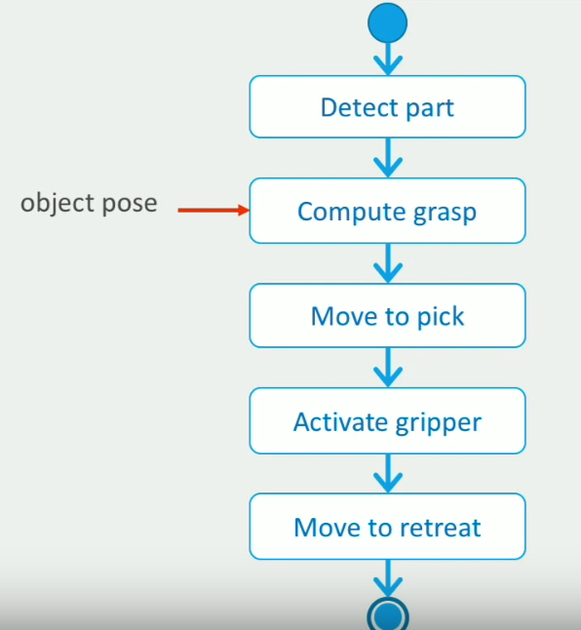
We start by filling the “Overview” section, which contains the basic information about a behavior.
---------------------------------------------------------------------------------------------------------------------
The StateMachine editor is the view you will use most of the time when developing behaviors in FlexBE.
Here is where we define our state machine by drag and drop and connecting states.
The flexbe_generic_states repository should include somethings useful.
The Tool Overlay is a very handy tool that you can activate by pressing “ control space”.
Ok, we already have the five states we need.
It is time to add the state transitions.
In the state machine editor, we define the state transitions by connecting each outcome of a state with the next state that should become active.

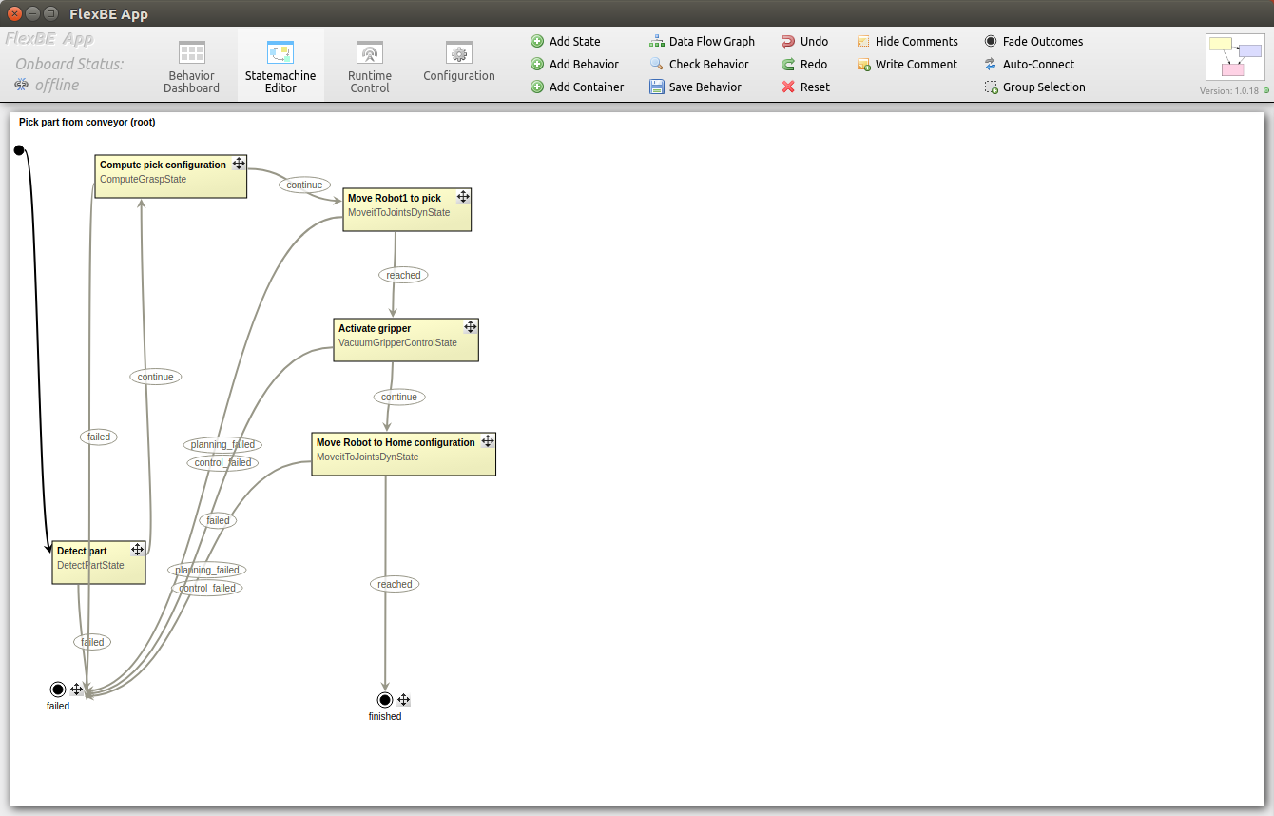
Then we need to add some parameter values we need for each state. To completely define our behavior, we need to configure these generic states, and also provide them with the run-time data inputs that they need to perform their actions.
---------------------------------------------------------------------------------------------------------------------
Let’s go back to the behavior dashboard view. This is where we will define the data for our behavior.
Constant data: data that doesn't change (example: location of the robot)
User data : Information that can change during the execution of our behavior, being passed between states. For example, in our behavior, the ‘Detect part’ state obtains the pose of the part to pick, which is used by the ‘Compute pick state’ to obtain the joint configuration the robot needs to move to pick the part.
Note that we always need to define a default value for each user data. This is like initializing a variable in programming.
---------------------------------------------------------------------------------------------------------------------
Now, we will configure the states in the state machine to use this behavior data.

Behavior Dashboard
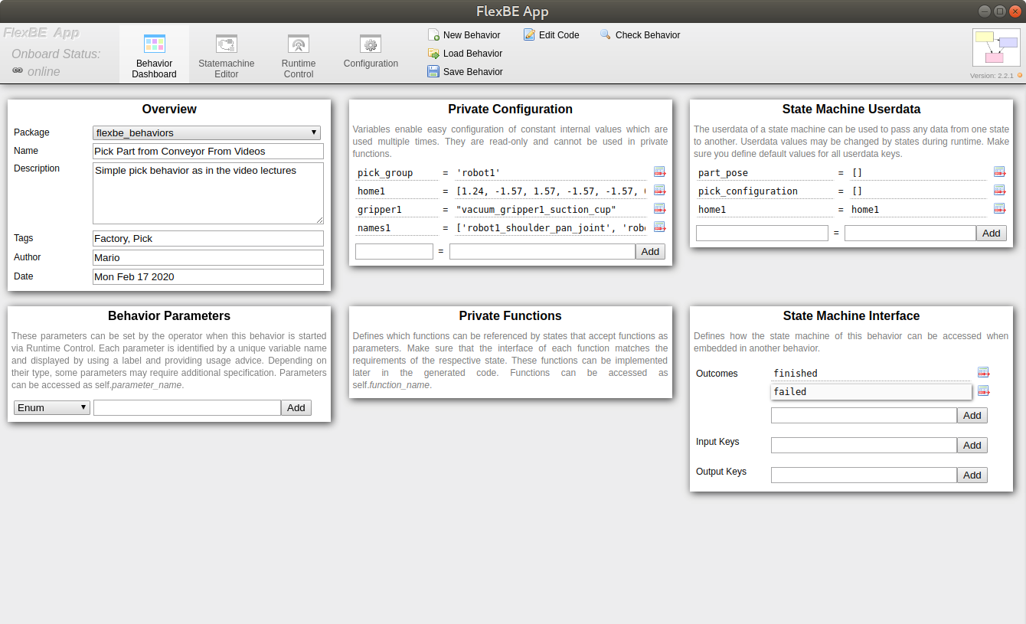
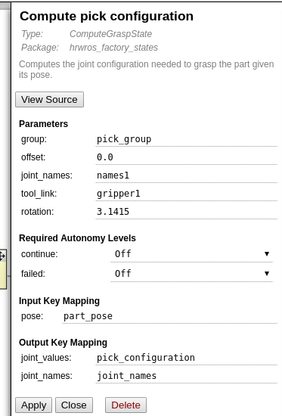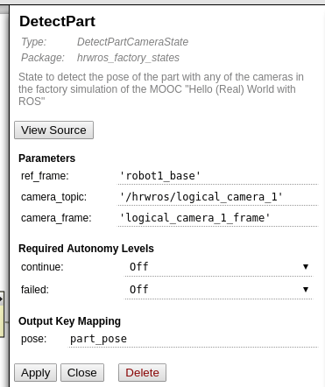
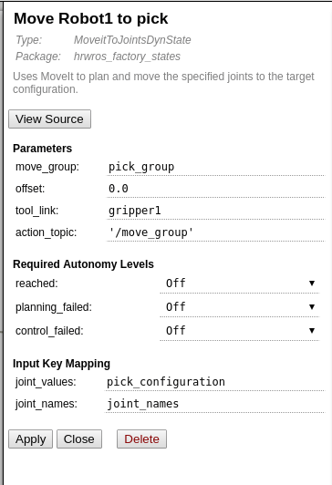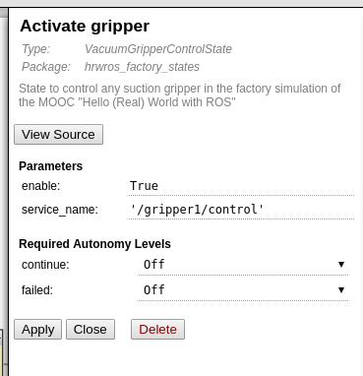
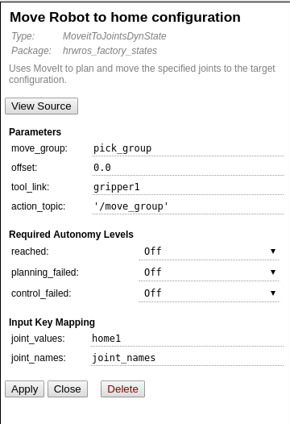
Allright now we save behavior.
Executing A Behavior
FlexBE allows to execute the behaviors.This is done in the Runtime Control view.
$ roslaunch hrwros_gazebo hrwros_pick_demo.launch
$ roslaunch flexbe_app flexbe_full.launch
Runtime Control --> load ‘Pick part from conveyor’ behavior --> Start Execution
*********************************************************************
So far we used available state implementations in FlexBE.
We can also create our own FlexBE state implementations.
How to create our own FlexBE state implementations
Examples: /hrwros_ws/src/hrwros_factory_states/src/hrwros_factory_states

